HOW TO CHECK YOUR RESULTS ONLINE

- Goto www. hillviewshs.ga

- Locate “ Goto Students Dashboard ” click on the link on the main page.
- At the Student Portal login page, enter your Student ID Number and then Password and finally click on “ Login to your account ”.

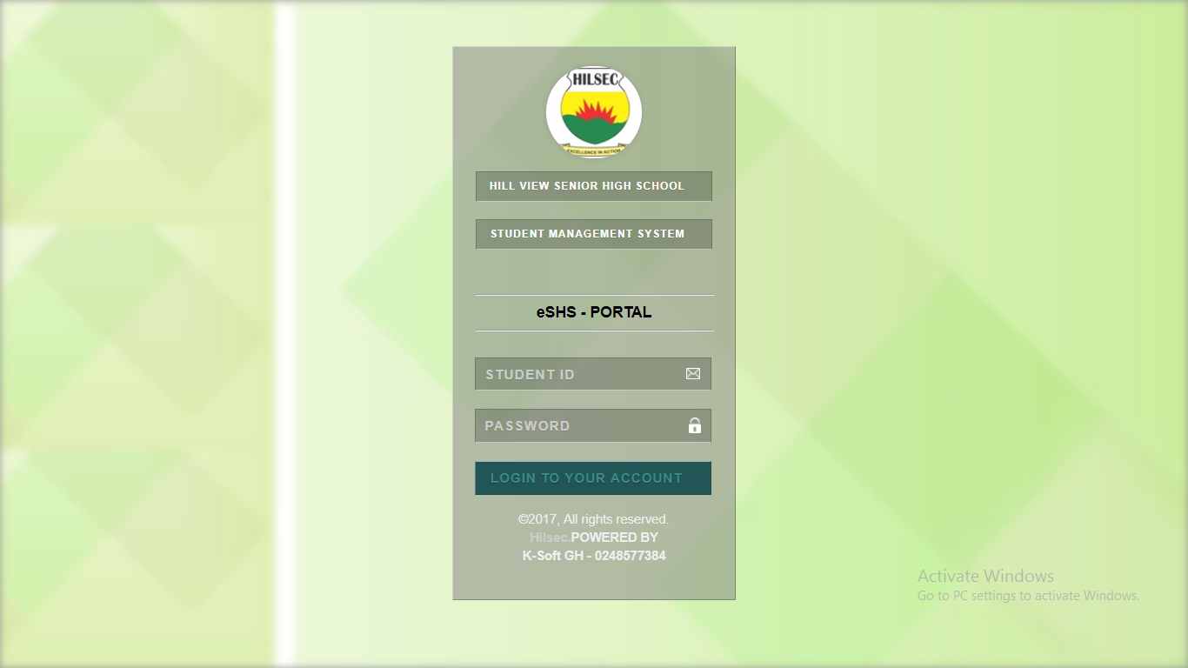
- Example :
STUDENT ID : 20150050
PASSWORD : hilsec ( default password )

- Now browse the application features and links
DASHBOARD :
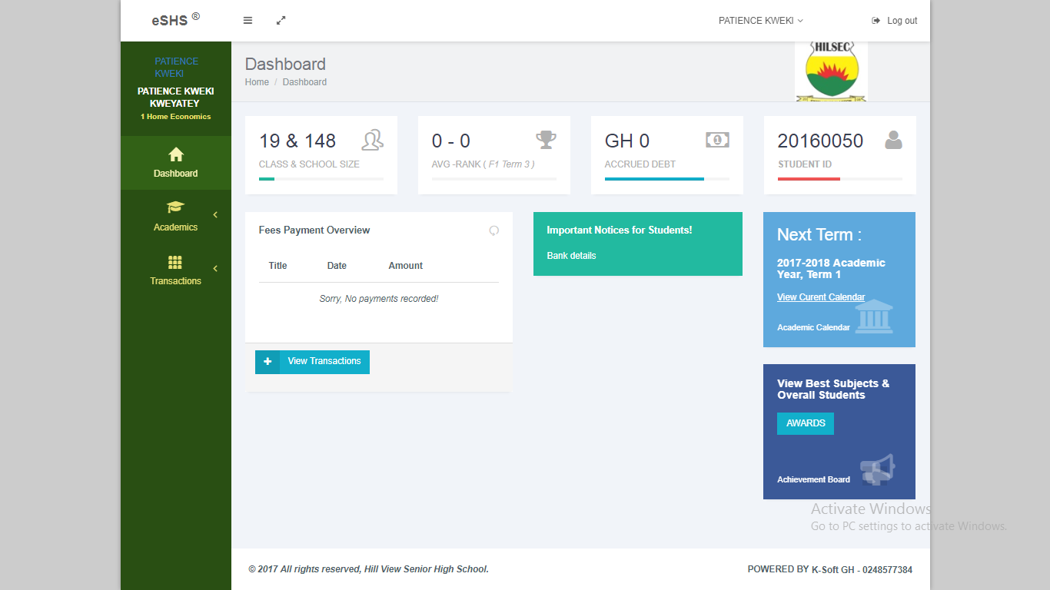

RESULTS : ( Goto Academics section > Results History )

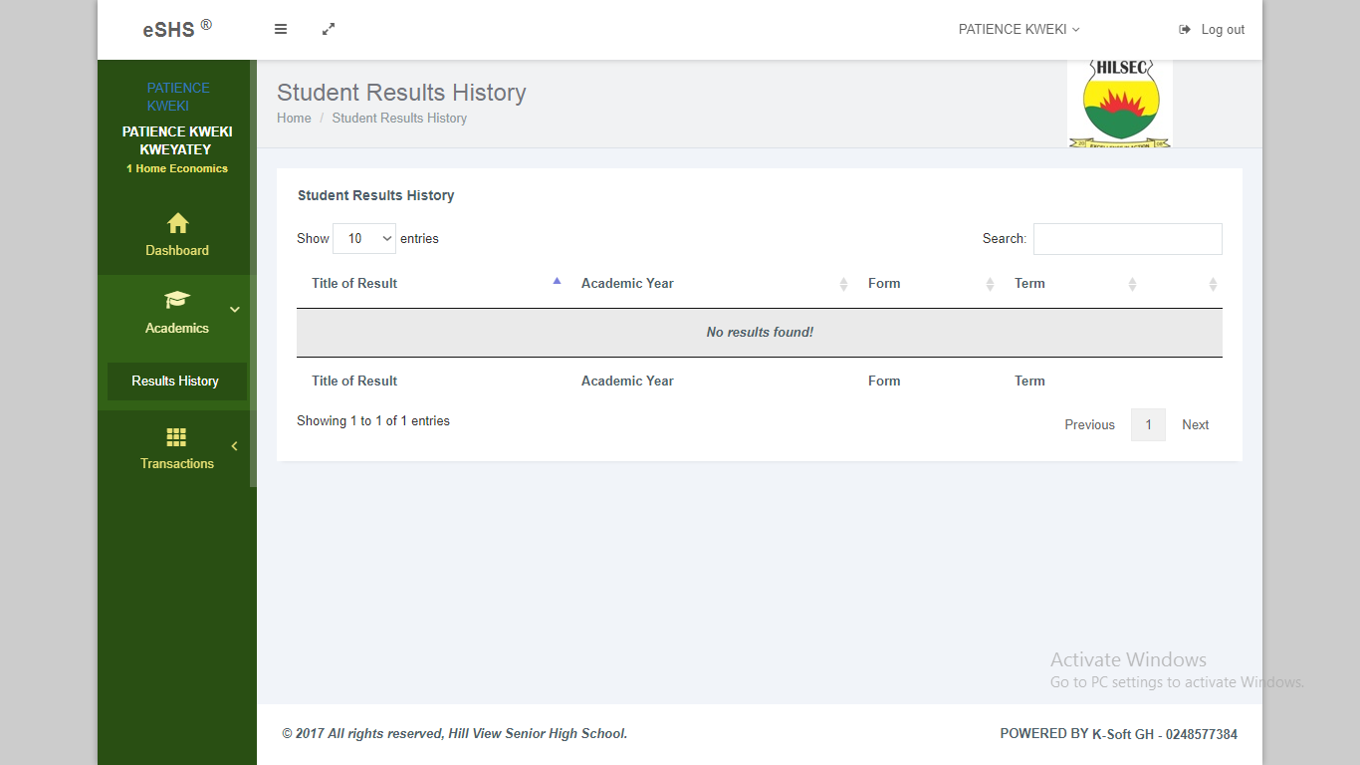

FEES : ( Goto Transactions section > Fees History )

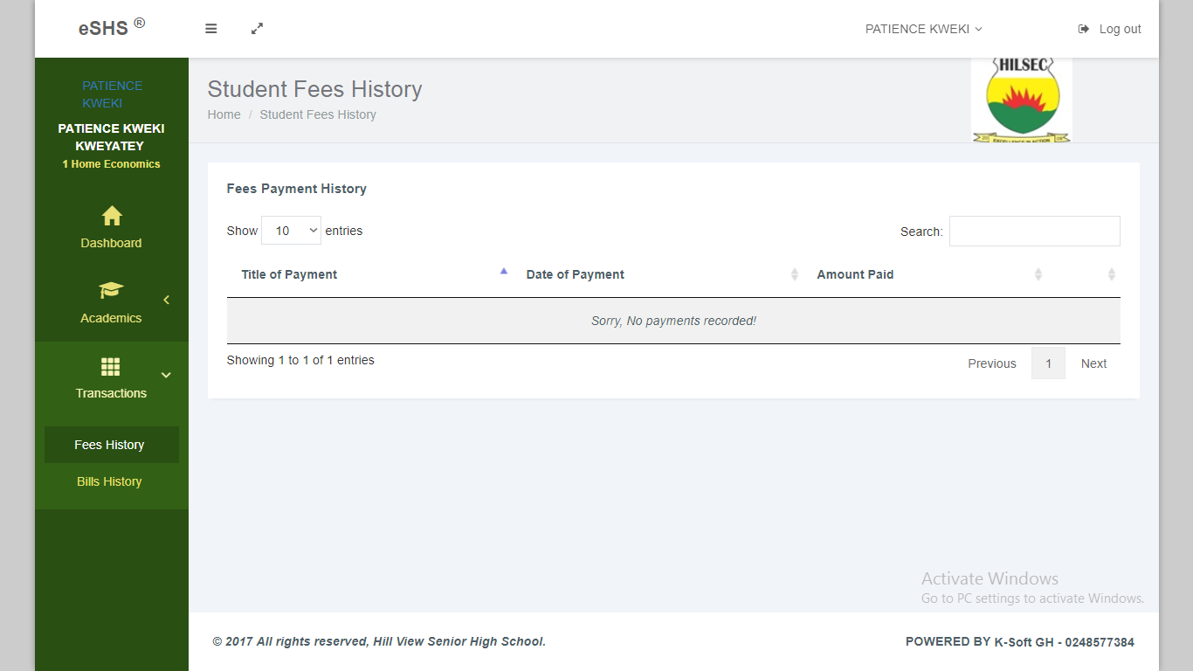

BILLS : ( Goto Transactions section > Bills History )

